

**Tribhuvan University**

**Faculty of Humanities and Social Science**

**Numerical Methods**

**A LAB REPORT**

**Submitted To**

**Department of Computer Application**

**Shahid Smarak College**

*In partial fulfillment of the requirements in the Bachelors in Computer Application*

Submitted By :

Amir Maharjan

TU Regd.No :

Exam Roll No :

**_______________**

**Internal Supervisor**

**Sandesh Bista**

**_________________**

**External Supervisor**

**Kirtipur Kathmandu**

Table of Contents

**Question 1:** WAP to compute the interpolation value at a specified value, given a set of table points using the natural cubic spline interpolation 1

**Question 2:** WAP to implement Bisection Method 2

**Question 3:** WAP to implement Newton Raphson Method 3

**Question 4:** WAP to implement secant method for solving non-linear equations**.** 4

**Question 5:** WAP to implement Fixed Point iteration method for solving non-linear equation. 5

**Question 6:** WAP to find the solution using gauss elimination method for system of linear equations. 6

**Question 7:** WAP to find the solution using Gauss Jordan Method for system of linear equations. 7

**Question 8:** WAP to find matrix inverse using gauss Jordan method for solving system of linear system**.** 8

**Question 9:** WAP to implement Gauss-Saidel method for solving of non-linear equations. 9

**Question 10:** WAP to implement Newton’s forward interpolation 10

**Question 11:** WAP to implement Lagrange Interpolation 11

**Question 12:** WAP to implement regression model 12

**Question 13:** WAP to find integration of a function using trapezoidal rule 13

**Question 14:** WAP to find the integration of a function using Simpson 1/3 rule. 14

**Question 15:** WAP to find integration of a function using Simpson 3/8 rule**.** 15

# **Question 1: WAP to compute the interpolation value at a specified value, given a set of table points using the natural cubic spline interpolation**

**Objective:** To compute the interpolation value at a specified value, given a set of table points using the natural cubic spline interpolation

**Program:**

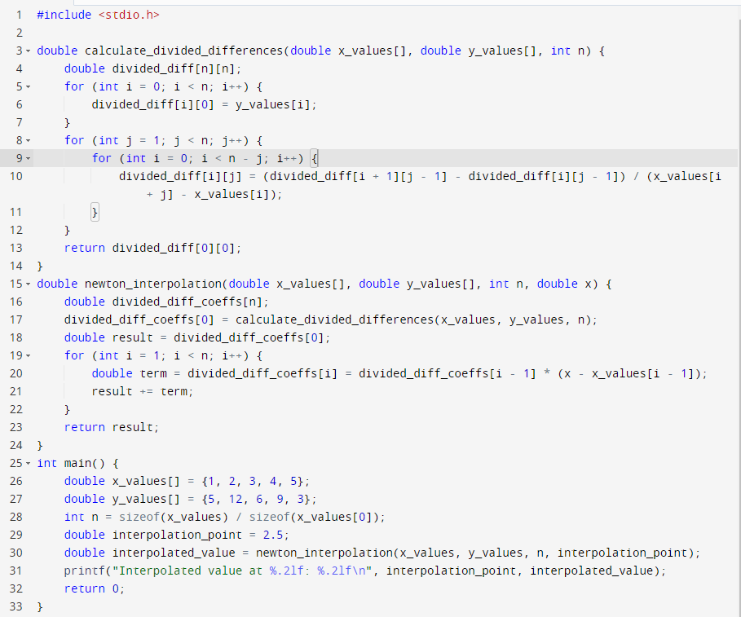

Output:



# **Question 2: WAP to implement Bisection Method**

**Objective:** To implement bisection method.

**Program:**

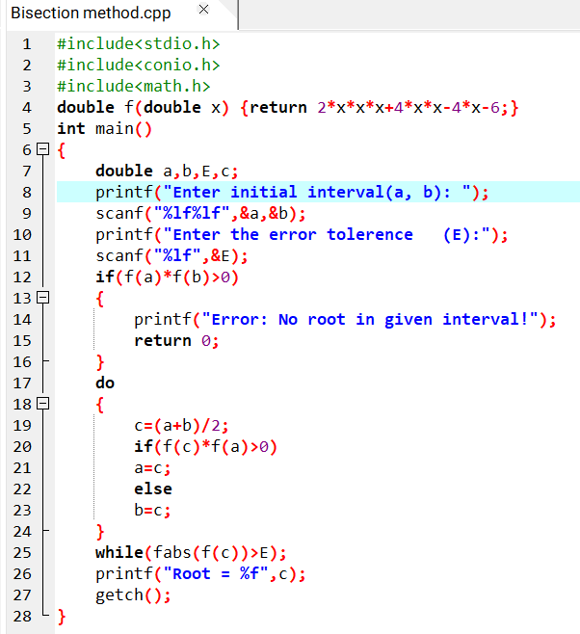

**Output:**

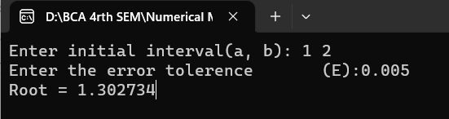

# **Question 3: WAP to implement Newton Raphson Method**

**Objective:** To implement Newton Raphson Method

**Program:**

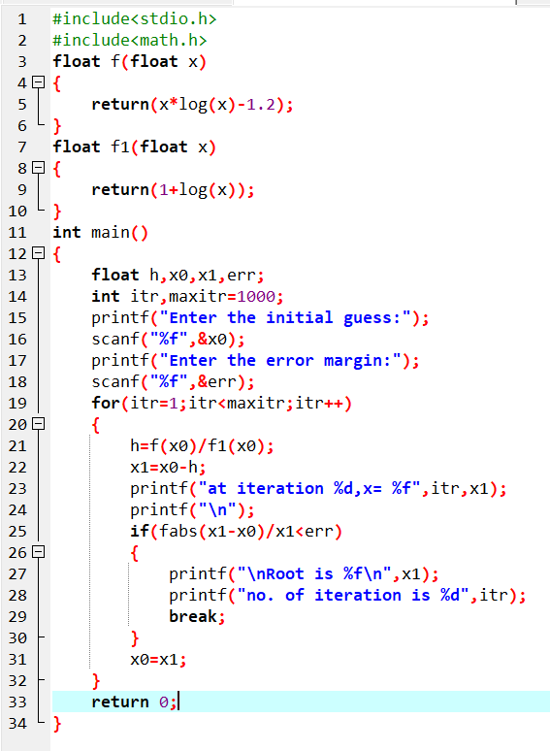

**Output:**

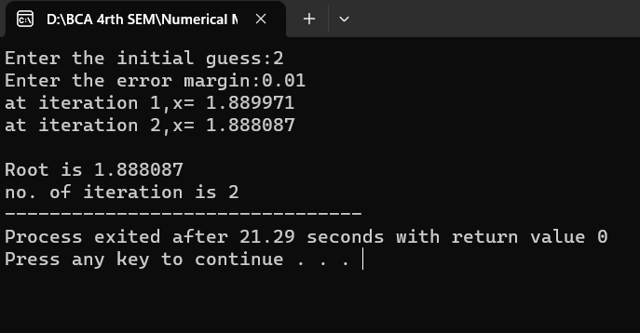

# **Question 4: WAP to implement secant method for solving non-linear equations.**

**Objective:** To implement secant method for solving non-linear equations.

**Program:**

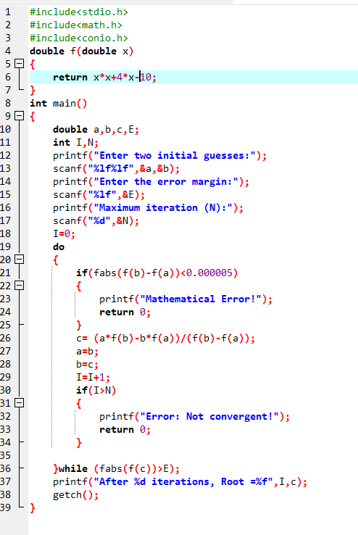

**Output:**

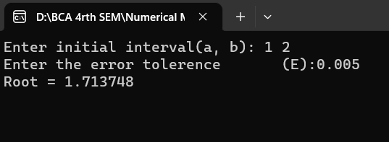

# **Question 5: WAP to implement Fixed Point iteration method for solving non-linear equation.**

**Objective:** To implement Fixed Point iteration method for solving non-linear equation.

**Program:**

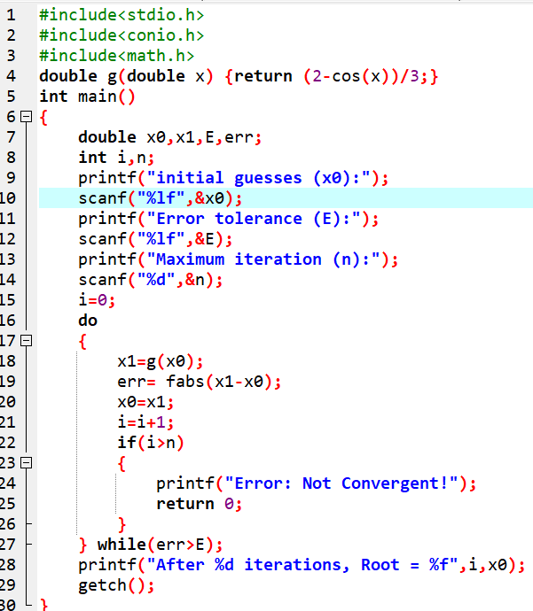

**Output:**

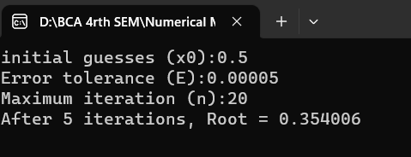

# **Question 6: WAP to find the solution using gauss elimination method for system of linear equations.**

**Objective:** To find the solution using Gauss Elimination Method for systems of linear equations.

**Program:**

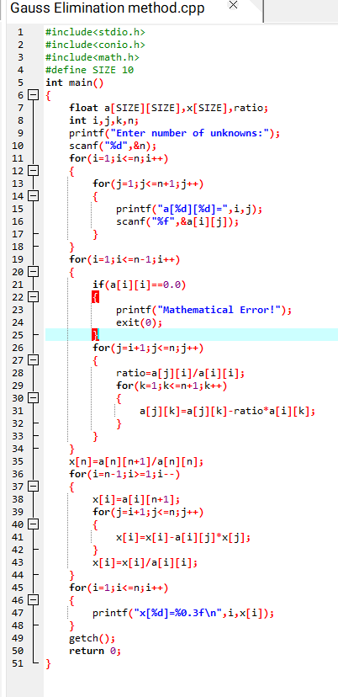

**Output:**

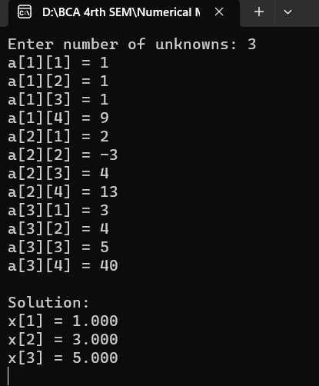

# **Question 7: WAP to find the solution using Gauss Jordan Method for system of linear equations.**

**Objective:** find the solution using Gauss Jordan Method for system of linear equations.

**Program:**

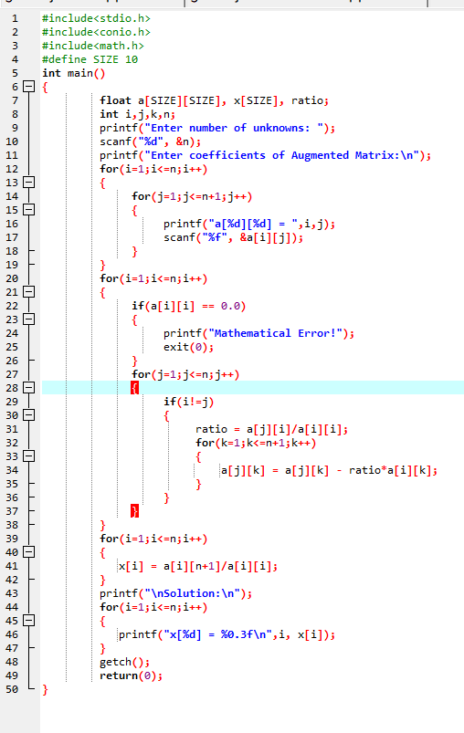

**Output:**

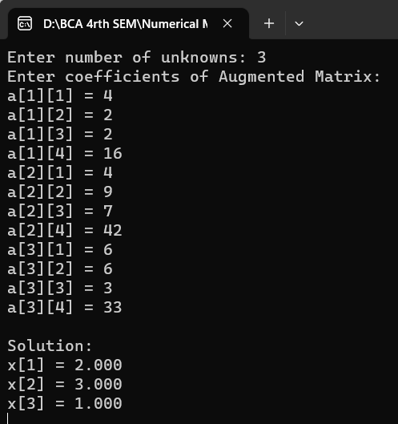

# **Question 8: WAP to find matrix inverse using gauss Jordan method for solving system of linear system.**

**Objective:** To find matrix inverse using gauss Jordan method for solving system of linear system.

**Program:**

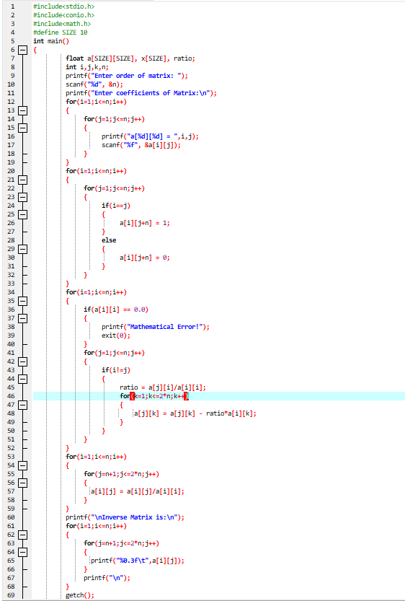

**Output:**

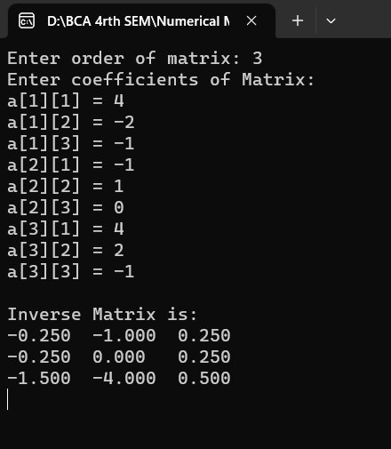

# **Question 9: WAP to implement Gauss-Saidel method for solving of non-linear equations.**

**Objective:** To implement Gauss-Saidel method for solving of non-linear equations.

**Program**

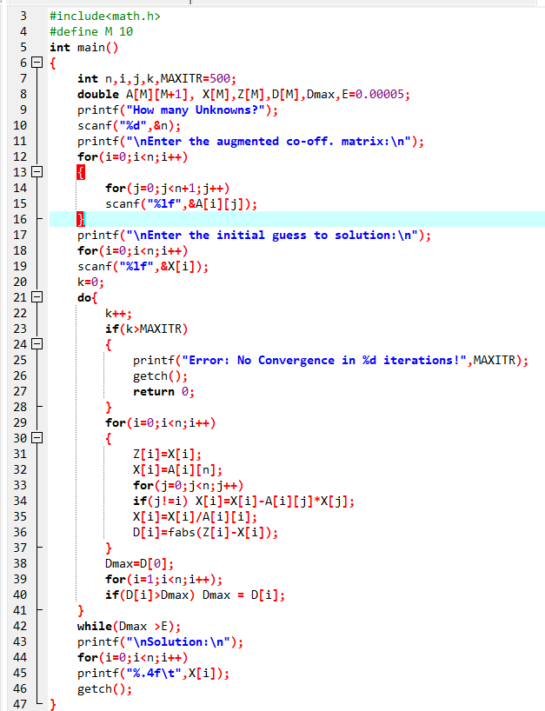

**Output**

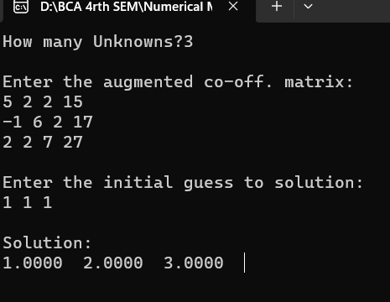

# 

# **Question 10: WAP to implement Newton’s forward interpolation**

**Objective:** To implement Newton’s forward interpolation

**Program**

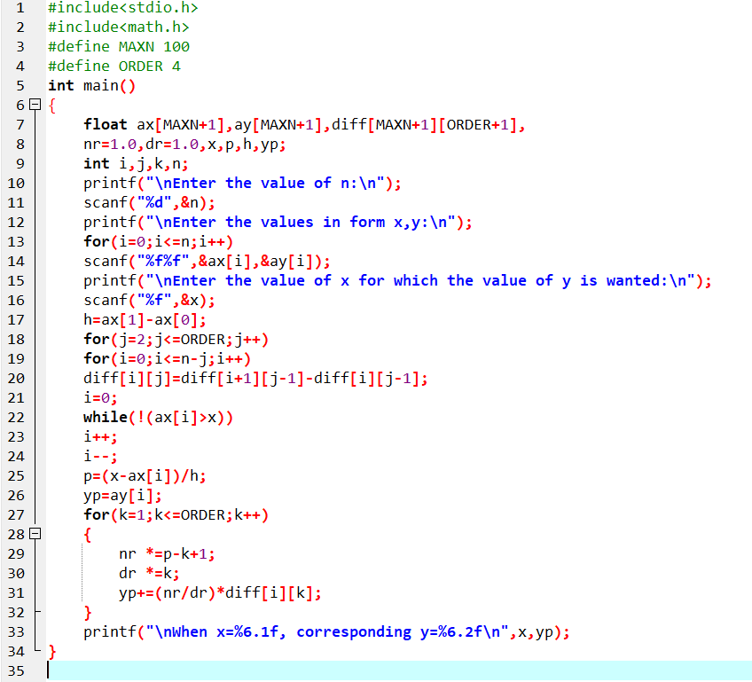

**Output**

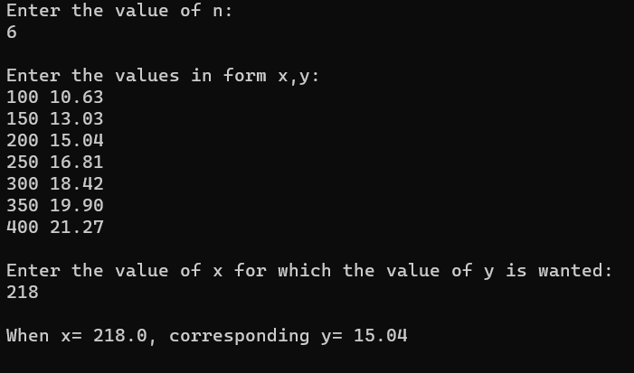

# **Question 11: WAP to implement Lagrange Interpolation**

**Objective:** To implement Lagrange Interpolation

**Program**

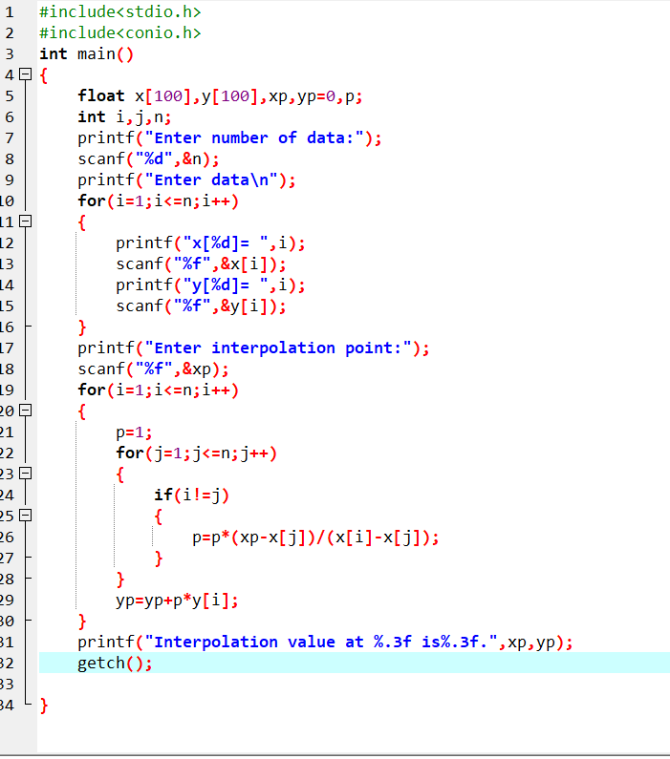

**Output**

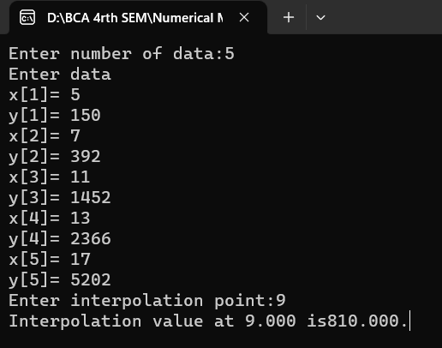

# **Question 12: WAP to implement regression model**

**Objective:** To implement regression model

**Program**

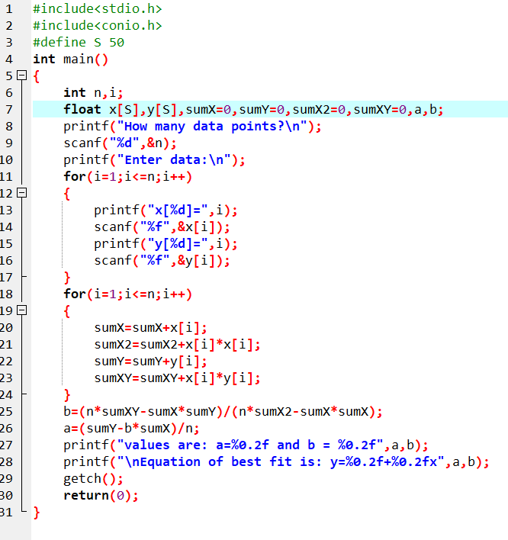

**Output**

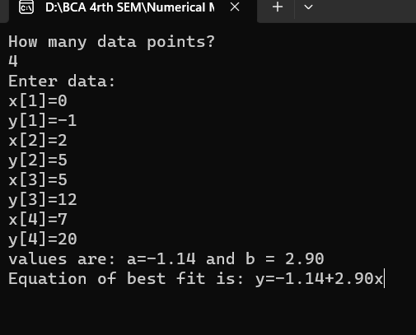

# **Question 13: WAP to find integration of a function using trapezoidal rule**

**Objective:** To find integration of a function using trapezoidal rule

**Program**

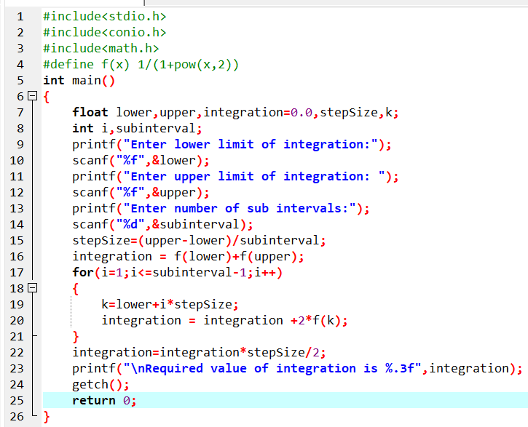

**Output**

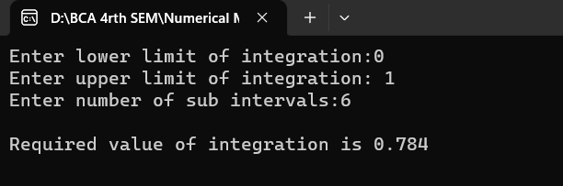

# **Question 14: WAP to find the integration of a function using Simpson 1/3 rule.**

**Objective:** To find the integration of a function using Simpson 1/3 rule.

**Program**

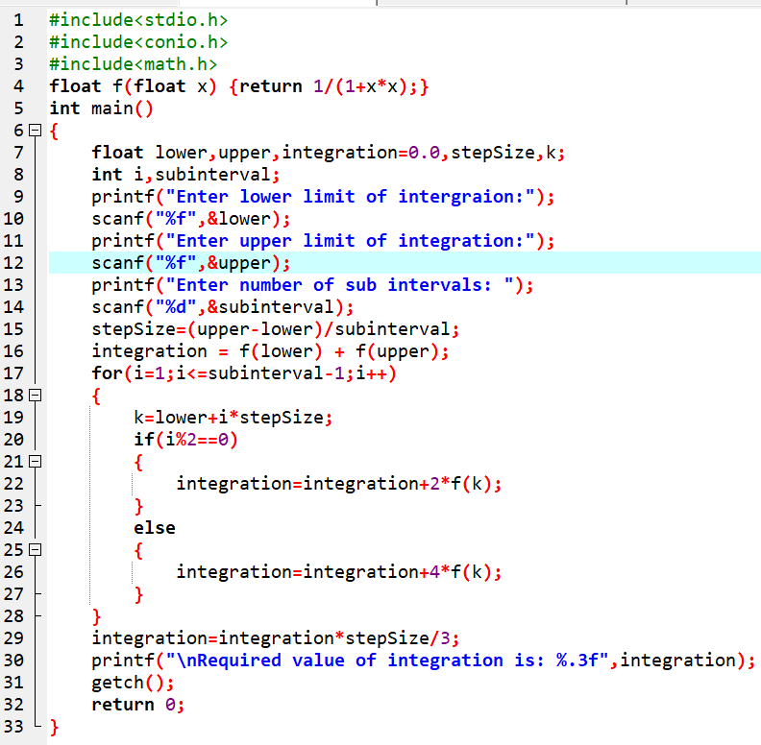

**Output**

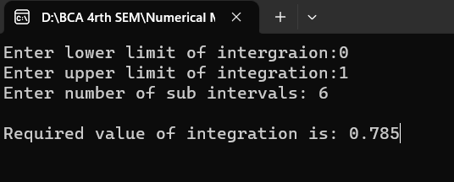

# **Question 15: WAP to find integration of a function using Simpson 3/8 rule.**

**Objective:** To find integration of a function using Simpson 3/8 rule.

**Program**

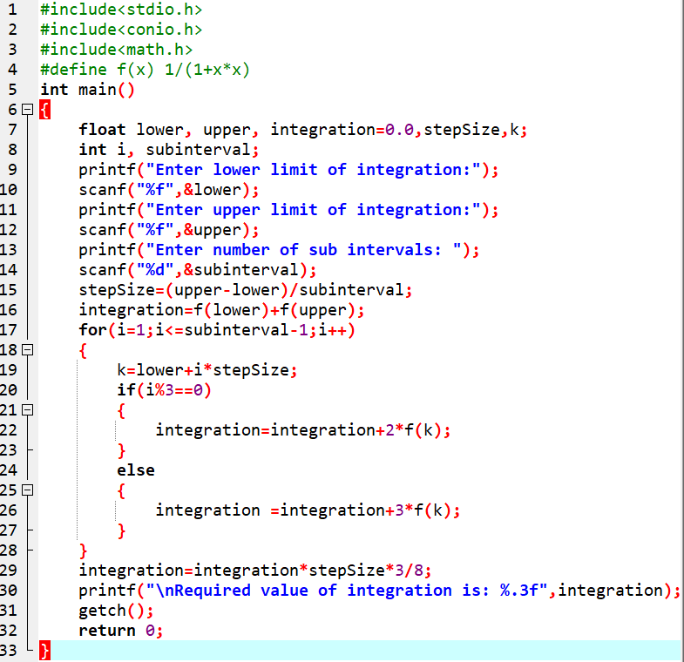

**Output**

